Author

author@resilienx.com

Basic API Integration: FRAIHMWORK Health And Integrity API

Contents

1 Introduction 2

2 API Endpoints and Concepts 3

2.1 Entities (“actors”) 3

2.2 Authentication Requests 3

2.3 Component Requests 4

2.3.1 Component Registration / Initial Reporting 4

2.3.2 Component Updates 6

2.3.3 Clearing Components 6

2.3.4 Refreshing Components and Component Liveliness 6

2.3.5 Field Descriptions 7

2.4 Faults 9

2.4.1 Fault Reporting 9

2.4.2 Fault Updates 10

2.4.3 Fault Clearing 11

2.4.4 Refreshing Faults and Fault Timeouts 11

2.4.5 Field Descriptions 12

2.5 Registration 13

2.6 Return objects 14

2.7 Specifications and Miscellaneous 14

3 Configuration 15

3.1 FRAIHMWORK Configuration Library 15

3.1.1 Default Data Fields 15

3.1.2 Representative Image 15

3.2 Fault Library 15

3.3 Timeouts 15

4 Security 16

5 Limitations And Future Work 17

# Introduction

Integration between an existing system and FRAIHMWORK means using the FRAIHMWORK provided APIs to relay component health information so that it can be processed by the FRAIHMWORK platform and ultimately displayed for a maintainer. This document will provide the high-level tasks that need to be completed to successfully integrate the two systems and provide a deeper explanation for the workflows and data concepts that are needed to make integration a success.

The scope of this document is limited to the APIs that we expect to be using for integrating these two platforms under this effort. Although other APIs are publicly exposed to other clients, they will not be necessary.

# API Endpoints and Concepts

All the API details are in the API specifications themselves. This section exists to provide context and explain some prerequisite concepts to help understand them.

## Entities (“actors”)

Entities include actors, such as human users and non-human services and system components. Actor types along with their respective definitions are shown below in Figure 1.

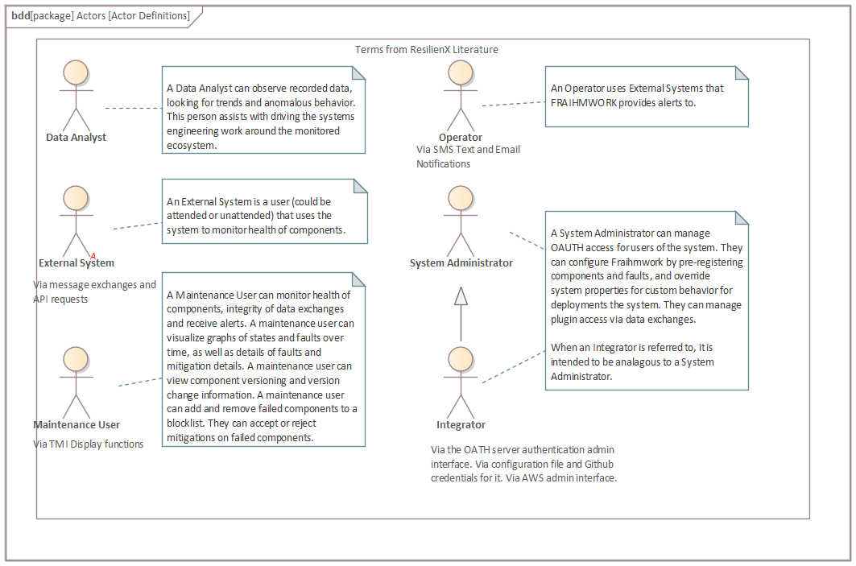

Figure : Actor Definitions

## Authentication Requests

Interaction with FRAIHMWORK via FRAIHMWORK API requests requires authentication using OAuth 2.0. Credentials are required for requesting an access token from the OAUTH server using an HTTPS request. Once the credentials are accepted by the OAUTH server, an access token and some additional information is provided in the response from the access request. All API requests to FRAIHMWORK must include the access token, otherwise an authentication error will result. This activity is shown in the sequence diagram, below (Figure 2).

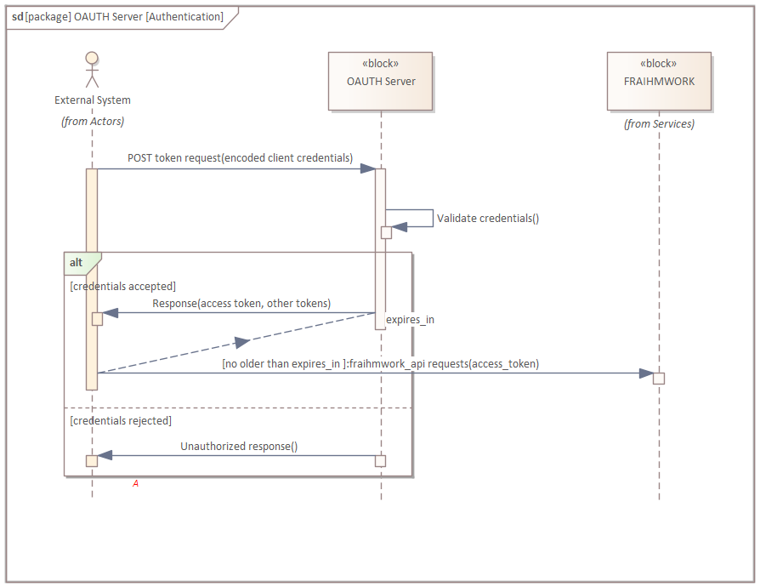

Figure : Authentication activity using OAUTH Server

For more information on authentication, see section 4, Security.

## Component Requests

External systems are made up of components. A component can be a complete system, or it can be one piece of many that make up a complete system. In the context of the API, a component is a monitored entity that can report its status over HTTP/S. The component object (“Monitored Component”) in the API represents all the facets of the component that FRAIHMWORK wants to record, digest, and, finally, portray on the TMI Display.

### Component Registration / Initial Reporting

When an external system or component wants to be monitored by FRAIHMWORK, it initiates a connection and posts its current component data, via the FRAIHMWORK Health and Integrity API as shown in Figure 3 below. Additionally, components can be POSTed by other systems on behalf of these components. This is common in case of components that are monitored, but do not have the ability to self-monitor or self-register.

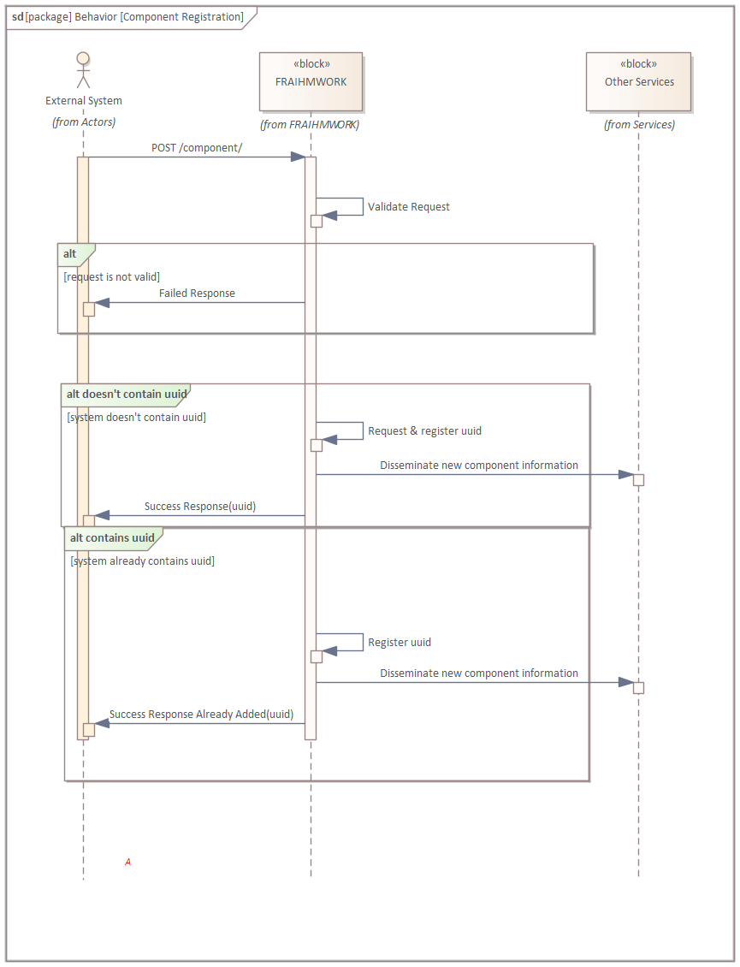

Figure 3: Initial Component Registration

If a component object is posted by an external system, then FRAIHMWORK will return the UUID of the newly registered component. If the component has a UUID that they already want to use, they can include it in the POST message and FRAIHMWORK will register that UUID instead of generating a new one.

### Component Updates

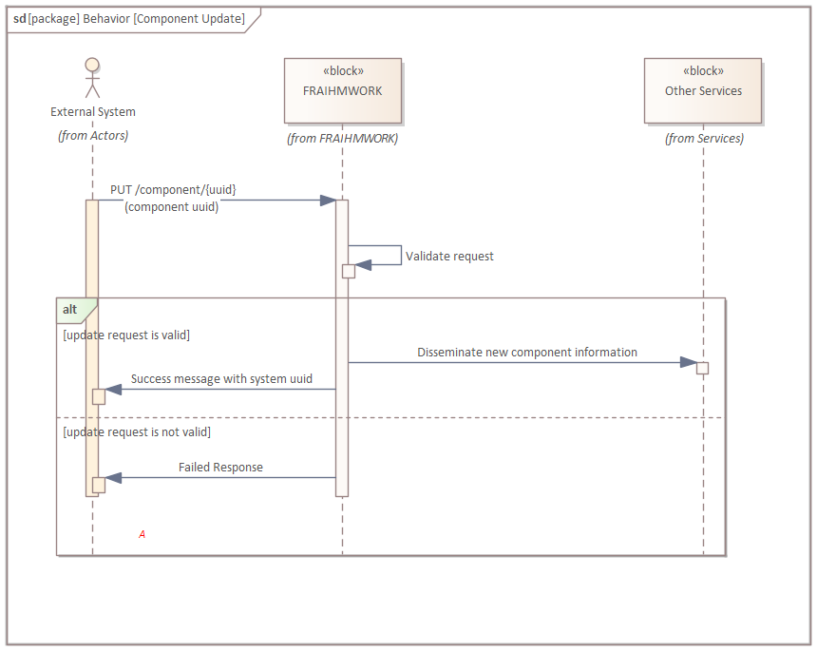

Figure 4: Subsequent Component Updates

For any subsequent updates to the component, due either to changes or as a keep alive measure, the HTTP PUT command is used in conjunction with the registered UUID, returned from the initial POST as seen in Figure 4.

### Clearing Components

The same pattern is used for deletion of components as is used with updating components, except the HTTP DELETE command is used instead.

### Refreshing Components and Component Liveliness

The FHAIS service requires a given component to be “refreshed” within a timeout period in the Monitored Component object data type. An empty POST request on the /component/{component uuid}/refresh is used for this action. If activity on that component is not provided to FHAIS, it will produce a liveliness fault. Additionally, a subsequent PUT on /component/{uuid} will also refresh component liveliness.

### Field Descriptions

Although some fields within the component object are self-explanatory, some require more detail and are further defined below.

#### State

Components can be described with one of the following states:

* STARTING_UP: Used to denote a component that will be providing services soon, but not yet.
* ONLINE: Used to describe a component that is operating normally
* FAULTED: Used for a component that has one or more faults against it that is affecting the quality of service
* UNAVAILABLE: Used to describe a component that cannot be reached. Generally, this state will not be reported by a component, but it could be used to describe a subsystem that the component/system relies on. Components in this state are not subject to liveliness checks.

The states that describe a component are depicted below in the following notional state diagram. Note, FRAIHMWORK does not enforce the transitions in this state diagram, rather, it is for informational purposes on how these states should be regarded by an integrator.

Figure 5 Monitored Component States

#### Versions

The data type provides several fields to describe the version of the component. These do not require strict interpretations, so long as they are consistently used to describe the same thing. Refer to semantic versioning as a widely accepted set of guidelines for versioning systems and components – [www.semver.org](http://www.semver.org).

#### Extra Properties (extensions)

The FHAIS API is designed to be flexible and allow for additional properties to be described in the extensions portion of the monitored component data type, if desired. Putting values here provides no guarantee of specific behavior within the FRAIHMWORK system but will be passed to any logging and data recording and will be passed to the display if customized rules are used for certain sites. For example, a radar system operating in a specific long range scanning mode may capture that in a ‘mode’ extra property so that it can be recorded by FRAIHMWORK (and possibly displayed if an adaptation was made for it on the display).

#### Parent

The concept of components and subcomponents exists in this API, and it is assumed that the client takes responsibility for reporting on all of them if it defines such a relationship. The field in the data type is optional and should only be used if there is an explicit ownership. In order to report on subcomponents, the process is the same, except that the UUID provided to the parent component should be used for this parent field. When there are subcomponents of a component, they should be registered from the highest level down, as show in Figure 6.

|  |  |
| --- | --- |
|  | Figure : Subcomponent (“parent-child”) Registration |

This order of operations ensures that the UUIDs of the parent component(s) are available to fill out the parent field of any subsystems.

#### Time of Validity

This is a timestamp that the client can provide to explicitly state when the data provided in the message was last accurate. If left blank, then the timestamp of receipt is assumed to be the time of validity. Although it can be left empty, it is useful to fill out this information for error tracing.

## Faults

Faults are any off-nominal condition that occurs within a system and its components. Anything that is outside the bounds of perfectly normal operation could be considered a fault, whether it is an atypical observation that has no impact or a serious communication error with another system.

### Fault Reporting

The workflow for reporting and updating faults is nearly identical to that for reporting and updating component information.

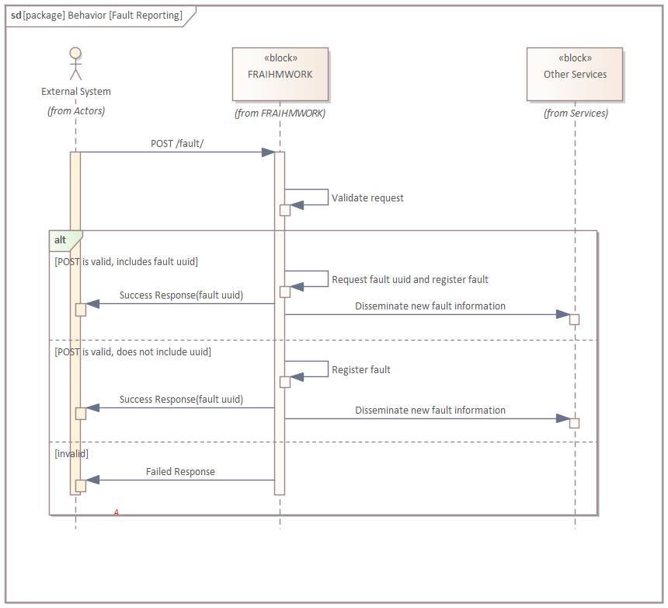

Figure 7: Fault Reporting

The fault is registered with a POST call, and FRAIHMWORK will attempt to honor the fault UUID if provided so long as it does not conflict with anything already registered in the system, otherwise, it will generate one for the fault instance resulting from the request. Registration of the fault UUID will happen under the hood, and the return value of the call will simply be a success message that includes the UUID that was accepted, or an error message with a null UUID field. A required parameter for the registration of the fault is the component UUID that the fault is concerned with.

### Fault Updates

To ensure that the fault is still active, FRAIHMWORK expects that updates or resends of the information will occur at certain intervals, or it will clear the fault due to inactivity.

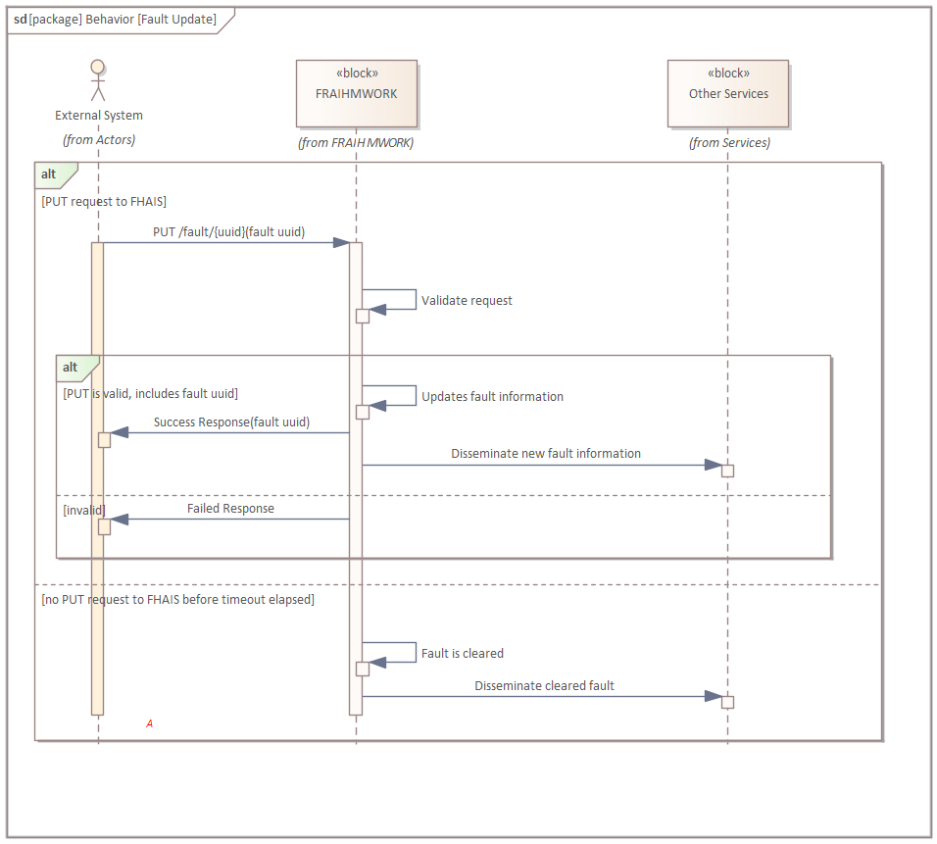

Figure 8: Fault Updating / Resending

To update or resend a fault, the HTTP PUT command is used with the UUID of the fault as a parameter. The dataflow is identical to that of resending or updating a component object from section 2.2.

### Fault Clearing

Faults need to be cleared when they are no longer active, and the way to do this is with the HTTP DELETE command with the UUID of the fault provided as a URL parameter.

### Refreshing Faults and Fault Timeouts

FRAIHMWORK expects that faults that persist in the environment should continue to be reported on. Therefore, a given fault needs to be “refreshed” within a timeout period in the Fault object data type. An empty POST request on the /fault/{uuid}/refresh (uuid denotes the fault uuid) is used for this action. PUT updates on the /fault/{uuid} endpoint also serve this purpose. If activity on that fault is not provided to FRAIHMWORK, the fault will be cleared automatically.

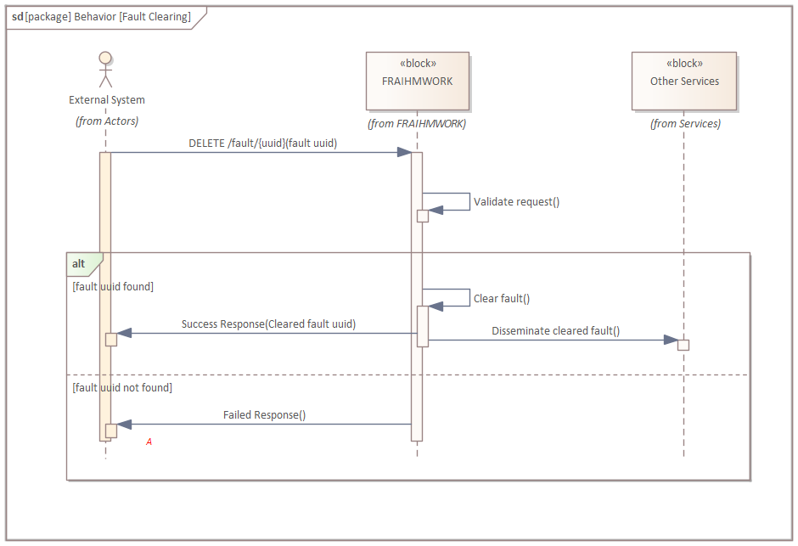

Figure 9: Fault clearing

Clearing a fault requires no additional payload of the latest fault status.

### Field Descriptions

Although some fields within the fault object are self-explanatory, some require more detail and are further defined below.

#### Severity

The severity of a fault indicates how impactful it is to the monitored component as a whole. This can range from “something the component notices” to “something that is causing failure within the component or system”. To capture this range, there are four levels of fault severities:

* LOW – The component is unaffected by this fault, but it is useful to log it for some reason, or could become a more severe fault over time
* MEDIUM – The component’s operational performance is suffering due to this fault, but the quality of information that it is producing is still reliable
* HIGH – The quality of service is affected and data is untrustworthy, due to it being incorrect, missing, or not meeting other necessary requirements
* UNKNOWN – This is generally reserved for when the source of the fault cannot be determined, and thus, the component does not understand its impact on operations. This should not be used in most use cases, as components should be aware of the faults that they can produce. In terms of fault evaluation within FRAIHMWORK, “UNKNOWN” is considered the highest severity.

#### Source

The UUID of the affected component that the fault is against. If this field is left blank, then it is equivalent to putting the UUID of the reporting system there.

#### Code

The fault code is a number that is a unique identifier for the type of fault that is being instantiated or referenced. A code should be persistent across all fault reporting, in that any two faults that have the same code should be the same type of problem. Conversely, two faults with different codes should not be reporting about the same exact problem. Partners should pre-plan their code mappings in the design phase (this is discussed in more detail in sections 3.2).

#### Time of Detection / Time of Validity

The time of detection is when the fault was first discovered. This should not change with any subsequent updates to the fault. If it is left blank, it is assumed that the time of receipt of the first POST message is the time of detection.

By contrast, the time of validity represents the most recent time that the fault was verified to still be active. For example, if the fault is caused by a failed hardware check that is performed every 3 minutes, the time of detection would be the first time it was detected, and the time of validity would change every 3 minutes when the check is made.

The time of validity is expected to be equal or later than the time of detection. If it is left blank, then it is assumed that the time of receipt of the most recent PUT message is the time of validity, which may or may not be the most accurate description.

## Registration

This API provides a mechanism for client systems to interact with the active list of components and faults within the FRAIHMWORK system. This is primarily useful to get the latest information about components that are monitored by FRAIHMWORK. It also provides the ability to generate new UUIDs for forthcoming API requests that use these as allocated identifiers.

Using an HTTP GET command on the /component endpoint will result in a full list of the active components in the system, which can be used to get the UUID information or other details for all components. Component information can also be requested by UUID by using GET on the /component/{uuid} endpoint as well.

Faults can be accessed similarly using the /fault/ and /fault/{uuid} endpoints. For more information, see the API specification for filtered queries and additional data type fields for the responses on these endpoints.

## Return objects

All the returned JSON objects contain a message that indicates success or failure, as well as the UUID that is relevant to the call that was made. For all component requests, the returned UUID is the UUID of the component information of data type ActiveComponent, being reported, or the new UUID generated by the post request. Similarly, the fault endpoint returns the ActiveFault data type, and the UUID is representative of the fault’s UUID that is being used to track it. If the UUID is null, this indicates that the component or fault was either not successfully created (in the case of an error), that it could not be found, or that it has been deleted.

## Specifications and Miscellaneous

All data sent to and returned from the APIs must be in JSON format as defined in [RFC 7159](https://tools.ietf.org/html/rfc7159). Therefore, it is expected that the HTTP ‘Accept Header’ is set to or includes JSON.

All timestamp information must be described as strings following ISO 8601 and must include time zone information if it is not presented as UTC.

The versioning of the APIs will follow SemVer 2.0.0 rules as described here <https://semver.org/>

# Configuration

In order to handle a wide variety of different clients, there are some assumptions that FRAIHMWORK must make in order to handle a number of different systems and components. These assumptions can be overridden with configuration, and clients may elect to provide configuration data if they have specific reporting requirements.

## FRAIHMWORK Configuration Library

The configuration library is a collection of descriptive configuration files that represent the minimum base of what is to be expected in each ecosystem. It is also where parameters can be entered to change how FRAIHMWORK monitors specific components and services.

### Default Data Fields

Many of the data fields that are present in the system information data object can be pre-populated in the configuration library entry. This is useful for when the system is present in the ecosystem’s configuration but is powered off or connectivity is disrupted. The data can still be presented as it is in the configuration entry, but the state will simply be changed to either OFFLINE or UNAVAILABLE depending on the circumstances.

### Representative Image

The Components Tier of the TMI Display can optionally show a picture of the component being monitored, or a logo or other image. The easiest way to provide this is with a .png image, though dynamic URLs for this could be used in the future.

## Fault Library

Beyond the basic name, code, and severity, which are all required fields in the Fault object, there are additional pre-configured fields that can be set to suggest general troubleshooting and remediations that can be taken by the maintainer. These will be shown on the TMI Display and provides the opportunity for much longer descriptions, what system reactions are being automatically taken, and what the maintainer can do to help remediate the problem. For this reason, it is important that fault codes are organized in a way such that they can uniquely identify different problems, so that they can be reused for this purpose.

## Timeouts

The system and fault endpoints both operate on the assumption that data is continually refreshed whenever changes occur. However, if a system is in a steady state, this could mean that there are no new data for hours or days. Therefore, timeouts can be configured to set a maximum amount of time that a client system will go before sending an update on its system or fault information. If this threshold is exceeded, then FRAIHMWORK assumes that connectivity has been disrupted and will generate a fault on its behalf.

# Security

The API specifies that the primary security protocol used for the endpoints is OAuth 2.0 (<https://tools.ietf.org/html/rfc6749>) authorization framework. The flow being used will be Client Credential, which is the typical use for interactions that do not involve an individual user. More detailed security information will be provided on a site-by-site basis depending on what, if any, authorization server exists. If none exists, FRAIHMWORK will provide its own service to stand in its place.

# Limitations And Future Work

At the time of writing, there are no inherent protections against bad actors within the ecosystem reporting an excess of faults, components, etc., nor are there explicit permissions set on objects created by a client. Future development on these APIs and the servers that resources can only be modified or deleted by the systems that initially create them.